Day 12 Lab

Question to be solved
Script Include 58, 62, 65, 71
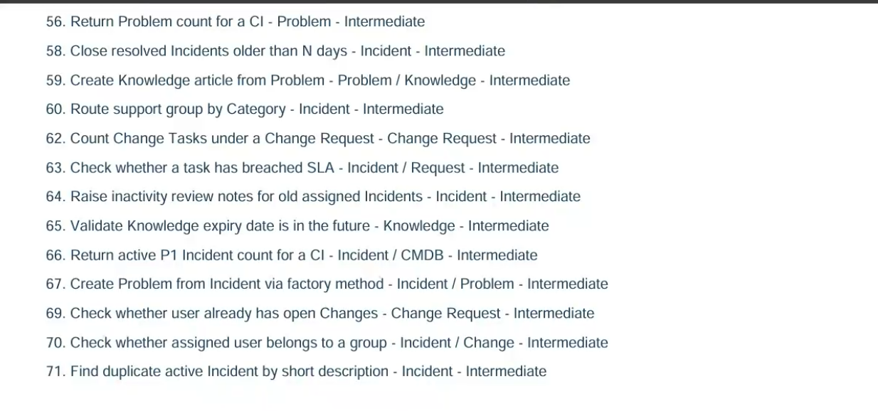

Script Include 58 Answer
58 Close resolved Incidents older than 10 days - Incident – Intermediate
Client script
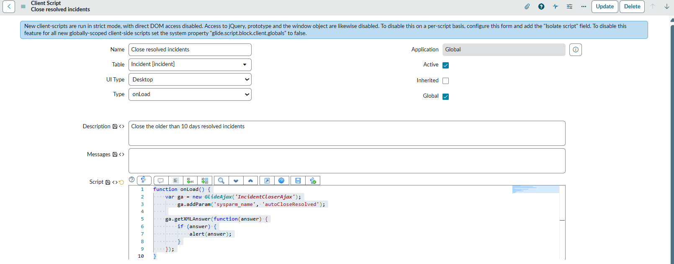
Script Include
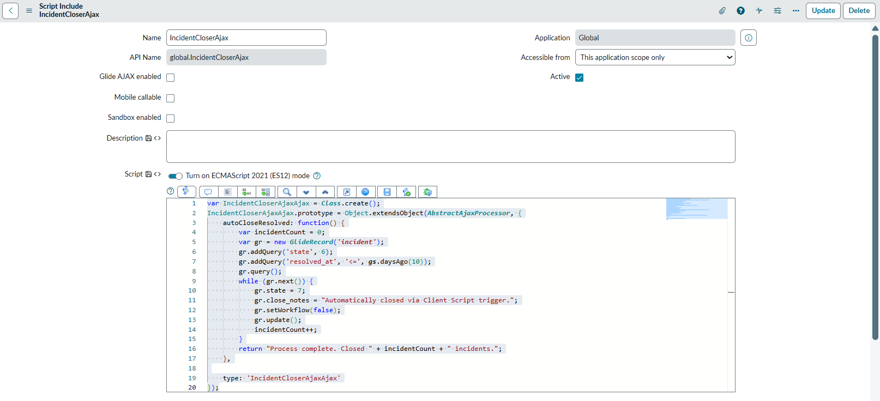

Script Include 62 Answer
62 Count Change Tasks under a Change Request - Change Request – Intermediate
Client script
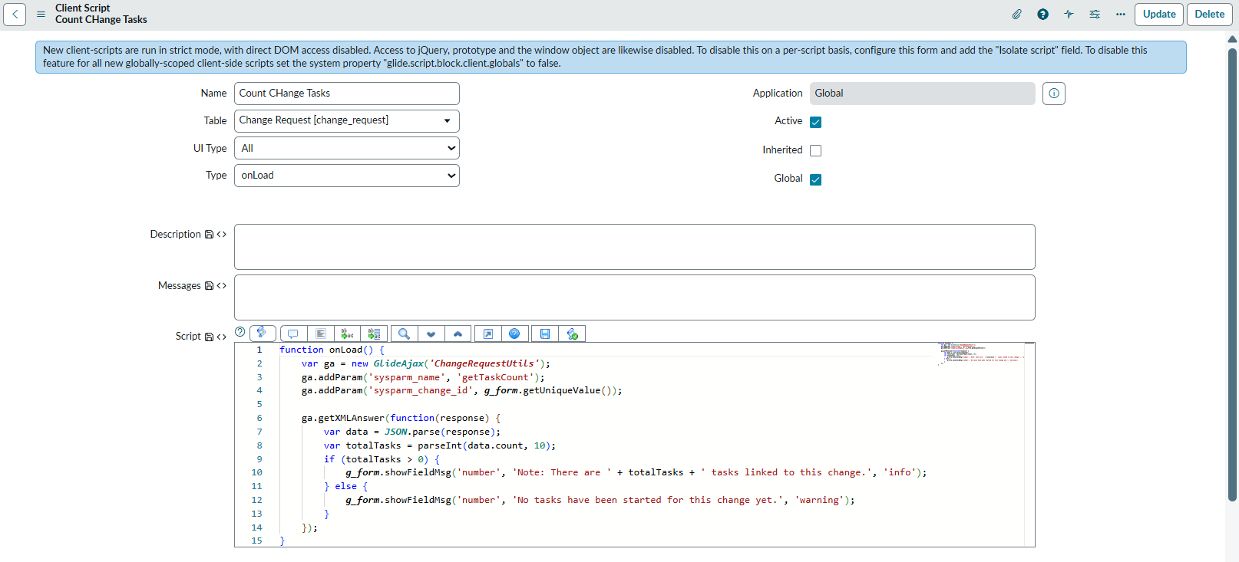
Script Include
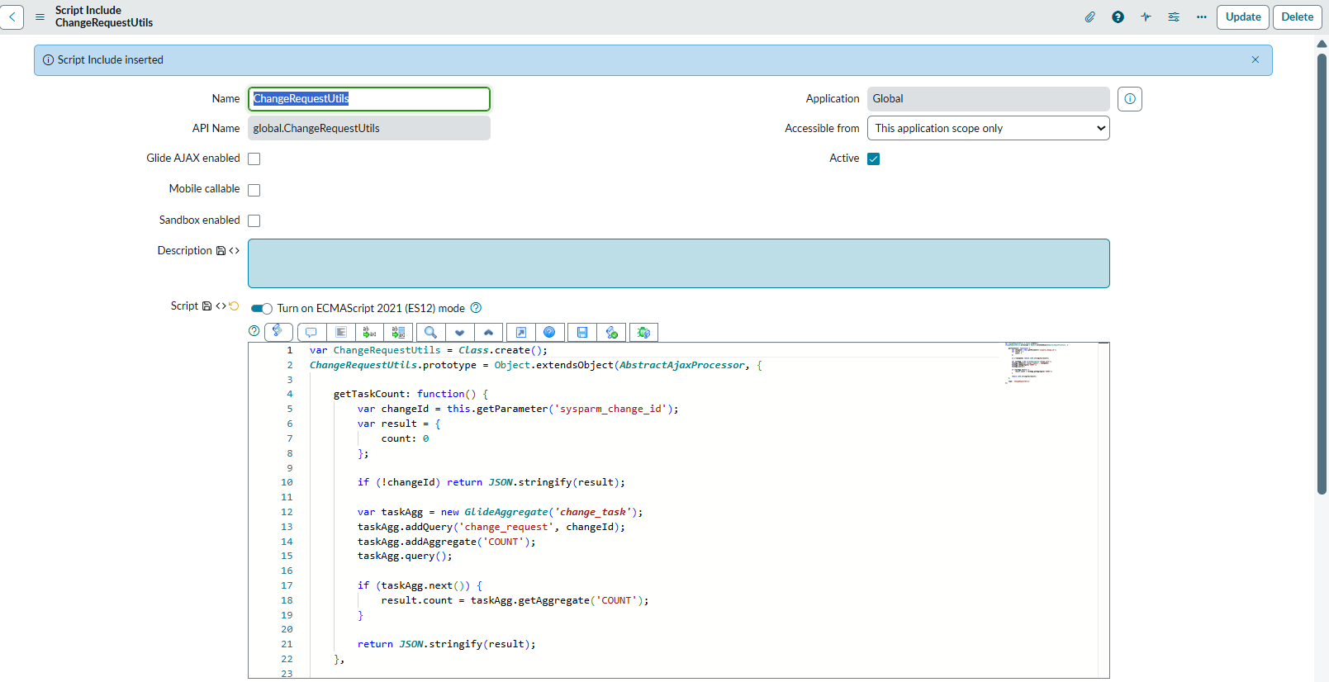

Script Include 65 Answer
65. Validate Knowledge expiry date is in the future - Knowledge – Intermediate
Client script
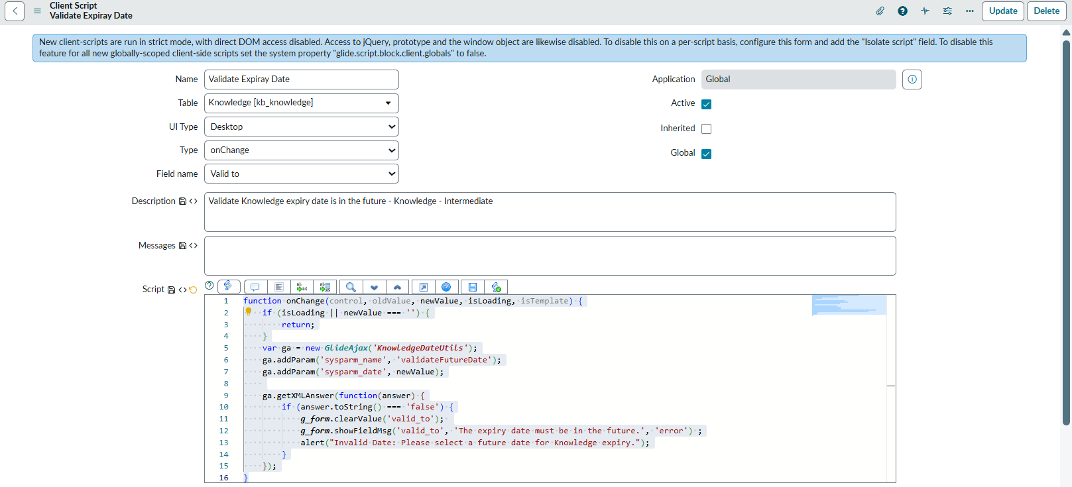
Script Include
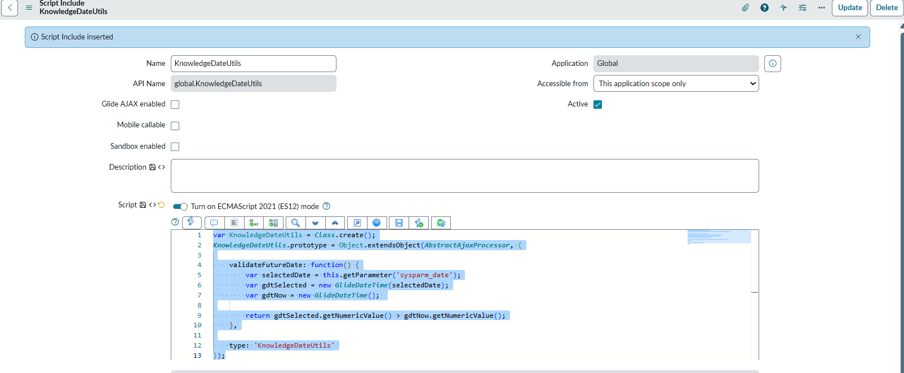

Script Include 71 Answer
71. Find duplicate active Incident by short description - Incident – Intermediate
Client script
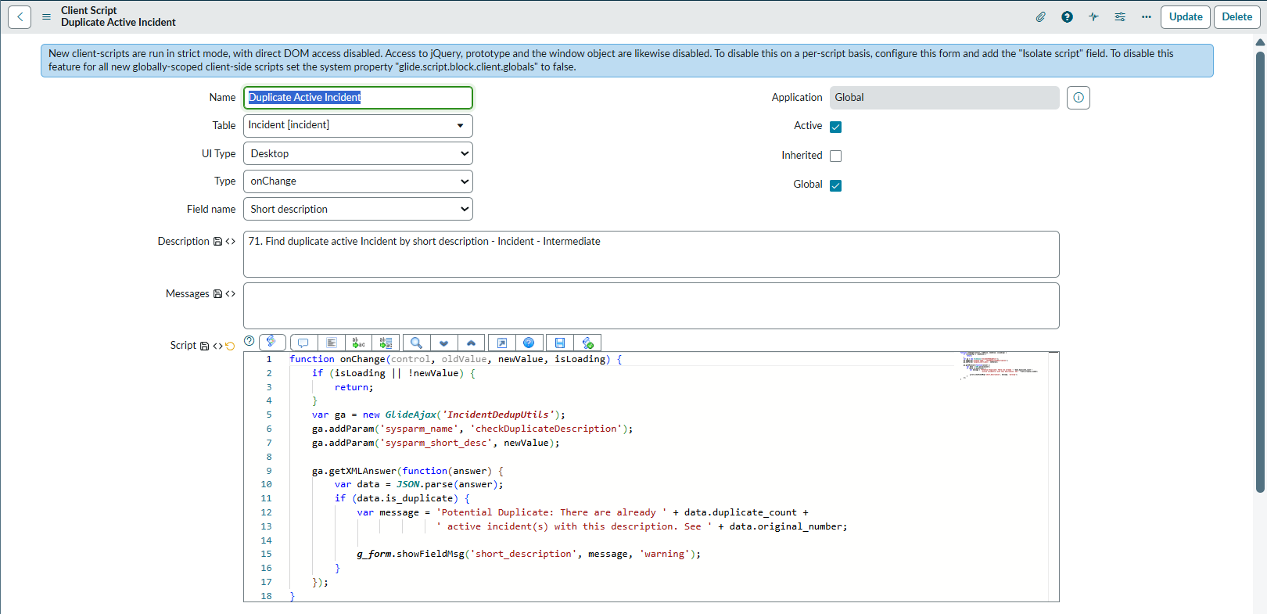
Script Include
